L&T Edutech Front end UI UX miniproject

Project 2:Delicious Recipe-Home

Submitted by :

Amal KJ (2460323) , amal.kj@btech.christuniversity.in

Austin K Lukose (2460342), Austin.k@btech.christuniversity.in

Tovin Tom (2460468), [tovin.tom@btech.christuniversity.in](mailto:tovin.tom@btech.christuniversity.in)

Course: UI UX fundementals

Instructor name :Narendra

Date of Submission:

**Abstract**

This project involves the development of an enhanced version of a personal portfolio website, hosted at **amal-kj123.github.io/l-t2**, with improvements in design, content structure, and interactivity. The site is built using core web technologies—HTML for structuring content, CSS for styling and layout, and JavaScript for adding dynamic behaviors. Through this version, the aim is to present the author’s academic background, personal qualities, and project work in a more refined, user-friendly interface.

The website is organized into several key sections such as **Home**, **About**, **Projects**, and **Contact**, with improved navigation and visual consistency. Multimedia elements including images and custom icons are integrated to make the content more engaging. Responsive design principles are used to ensure the site adapts seamlessly to different devices, including desktops, tablets, and smartphones. The upgraded version also focuses on performance optimization, clean code structure, and enhanced usability. Deployed via GitHub Pages, the portfolio allows the author to maintain a professional online presence. This improved version not only showcases technical growth but also serves as a foundation for future enhancements like interactive forms, project demos, and backend connectivity.

**Objectives**

1. **To design and develop an improved version of the personal portfolio website** that presents academic background, skills, and projects in a more professional and user-friendly format.
2. **To apply front-end technologies such as HTML, CSS, and JavaScript** in creating a well-structured, styled, and interactive web interface with enhanced usability.
3. **To implement responsive design strategies** that ensure the website adapts seamlessly to different devices and screen sizes, providing a consistent browsing experience.
4. **To organize content into clear sections** such as Home, About, Projects, and Contact, allowing visitors to navigate smoothly and find relevant information easily.
5. **To enhance the visual appeal of the site** by using multimedia elements such as images, icons, and design effects, making the portfolio engaging and modern.
6. **To establish a stronger digital identity** by deploying the updated portfolio on GitHub Pages, ensuring accessibility for peers, educators, and potential employers.

**Scope of the Project**

1. **Personal Branding:** The portfolio serves as a platform to highlight the author’s academic details, skills, and achievements in a professional way.
2. **Practical Web Development Application:** The project allows hands-on use of HTML, CSS, and JavaScript for building and styling a functional website.
3. **Responsive Design:** The website is designed to adapt to desktops, tablets, and smartphones, ensuring accessibility across multiple devices.
4. **Organized Content Presentation:** Structured into Home, About, Projects, and Contact sections, the site makes information easy to locate and understand.
5. **Improved User Experience:** Visual elements, smooth navigation, and interactive features are included to make the website more engaging.
6. **Professional Communication:** The contact section provides channels for visitors to connect, encouraging collaboration and career opportunities.
7. **Future Expandability:** The project can be extended with advanced features such as blogs, interactive forms, and project demonstrations, making it scalable for future needs.

|  |  |
| --- | --- |
| Tools/Technology | Purpose |
| **HTML (HyperText Markup Language):** | Used to structure the content of the website, including text, headings, images, and links across different pages. |
| **CSS (Cascading Style Sheets):** | Applied to style the website with layouts, colors, fonts, and responsive designs, ensuring the site looks visually appealing. |
| **JavaScript:** | Provides interactivity and dynamic functionality, such as smooth navigation, animations, and enhanced user engagement. |
| **GitHub & GitHub Pages:** | GitHub is used for version control and collaboration, while GitHub Pages hosts the portfolio website online for free. |
| **Visual Studio Code (VS Code):** | Serves as the primary code editor for writing, testing, and debugging the HTML, CSS, and JavaScript files efficiently. |
| **Image Assets (Profile & Project Images):** | Integrated into the site to make the portfolio more engaging and to visually represent projects and personal identity. |

HTML Structural View

The HTML structural view represents the framework of the portfolio website, showing how different components are arranged and connected. The document begins with <!DOCTYPE html>, which specifies that the page uses HTML5. The root <html> tag encloses all the content and is divided into two main sections: <head> and <body>.

The <head> section contains metadata, including the page title, character encoding, viewport settings for responsiveness, and links to external resources such as CSS stylesheets. These elements ensure proper rendering, consistent design, and smooth functioning across devices.

The <body> section contains all visible content of the website. It starts with a **header and navigation bar** implemented using <header> and <nav>, providing links to key sections such as Home, About, Projects, and Contact. The **main content** is divided into semantic <section> elements:

* **Home Section:** Displays the author’s introduction and profile image.
* **About Section:** Provides educational background and personal details.
* **Projects Section:** Lists projects with descriptions or images.
* **Contact Section:** Offers details like email and social links for communication.

Finally, a **footer** (<footer>) concludes the page with credits or copyright information.

This structured layout improves readability, accessibility, and navigation, while also making the website easier to maintain and expand in the future.

**CSS Styling Strategy**

The CSS styling strategy for the *l-t2 portfolio website* focuses on achieving a balance between simplicity, professionalism, and user engagement. A **global style sheet** is applied to maintain consistency in font families, background colors, and text alignment throughout the site. A minimal and professional **color scheme** is chosen, with contrasting colors for headings, links, and buttons to ensure readability and highlight important content.

**Typography hierarchy** is carefully maintained: headings are styled with larger and bolder fonts, subheadings with medium emphasis, and body text with a clean, readable font. Adequate spacing, padding, and margins are used to organize elements, preventing clutter and improving visual structure.

The **navigation bar** is styled for clarity, with hover effects that guide the user’s attention and improve interactivity. Each section, such as Home, About, Projects, and Contact, uses unique styling elements like borders, shadows, or background variations to create visual separation. **Images and icons** are styled with rounded edges, shadows, and responsive sizing to blend smoothly with the overall layout.

Finally, **media queries** are applied to ensure the website is fully responsive across desktops, tablets, and mobile devices. This ensures the portfolio remains functional, accessible, and aesthetically pleasing on all screen sizes.

|  |  |
| --- | --- |
| **Features** | **Description** |
| **Home Page Introduction:** | A welcoming section that displays the author’s name, profile image, and a brief introduction, creating the first impression for visitors.. |
| **About Me Section:** | Provides details about the author’s educational background, personal qualities, and career aspirations, helping visitors understand their profile better. |
| **Projects Showcase:** | Displays a list of completed projects such as web applications, games, or academic works, with descriptions and images to highlight practical skills. |
| **Contact Information:** | Contains essential details like email, GitHub, or LinkedIn links, enabling visitors to easily connect for collaboration or opportunities. |
| **Navigation Bar:** | A simple and clear menu that links to different pages (Home, About, Projects, Contact), allowing smooth browsing across the website. |
| **Responsive Design:** | Ensures the website adapts well to various devices, including desktops, tablets, and smartphones, maintaining readability and usability.. |

|  |  |
| --- | --- |
| **Challenges** | **Solution** |
| **Maintaining a clean and structured layout for multiple sections.** | Used semantic HTML tags (<section>, <header>, <footer>) and a grid-based CSS layout to organize content effectively. |
| **Making the website responsive on different devices.** | Implemented CSS media queries and flexible units (%, em, rem) to ensure adaptability on desktops, tablets, and smartphones. |
| **Achieving a professional visual design with limited resources.** | Applied consistent color schemes, typography hierarchy, and CSS effects such as shadows and hover transitions for modern styling. |
| **Ensuring smooth and intuitive navigation.** | Designed a fixed navigation bar with anchor links, making it easy for users to jump between sections without confusion. |
| **Presenting projects in an engaging way.** | Added descriptive text, images, and a structured layout for projects, making them easy to browse and understand. |
| **Hosting and maintaining accessibility of the portfolio.** | Used GitHub Pages for free, reliable hosting and version control to update the site efficiently. |

**Outcomes**

1. **Professional Online Presence:** Successfully created a digital portfolio that highlights academic background, skills, and projects in a structured manner.
2. **Practical Application of Web Technologies:** Gained hands-on experience in HTML, CSS, and JavaScript, strengthening front-end development skills.
3. **Improved Design Skills:** Learned how to apply color schemes, typography, and layout strategies to produce a visually appealing website.
4. **Responsive Web Development:** Implemented designs that adapt to multiple devices, ensuring accessibility across desktops, tablets, and mobiles.
5. **Project Showcase Platform:** Built a centralized space to display personal and academic projects, making them easy to share with peers, educators, and recruiters.
6. **Enhanced Problem-Solving Skills:** Overcame challenges such as layout issues, responsiveness, and optimization through structured solutions.
7. **Deployment Experience:** Successfully hosted the website using GitHub Pages, gaining knowledge of version control and live deployment.

**Future Enhancements**

1. **Interactive Contact Form:** Add a functional form with validation and email integration to enable direct communication with visitors.
2. **Project Demos and Links:** Include live project previews or GitHub repository links to allow users to explore work in detail.
3. **Dark/Light Mode Toggle:** Implement a theme-switching feature to enhance user experience and personalization.
4. **Blog or Articles Section:** Introduce a space for writing blogs or technical articles to showcase knowledge sharing and continuous learning.
5. **Advanced Animations:** Use JavaScript libraries or CSS animations for smoother transitions, hover effects, and section reveals.
6. **Backend Integration:** Connect the website with a database or CMS to manage content dynamically instead of manual updates.
7. **SEO and Analytics:** Improve visibility through search engine optimization and track visitor interactions using Google Analytics.

Sample Code:

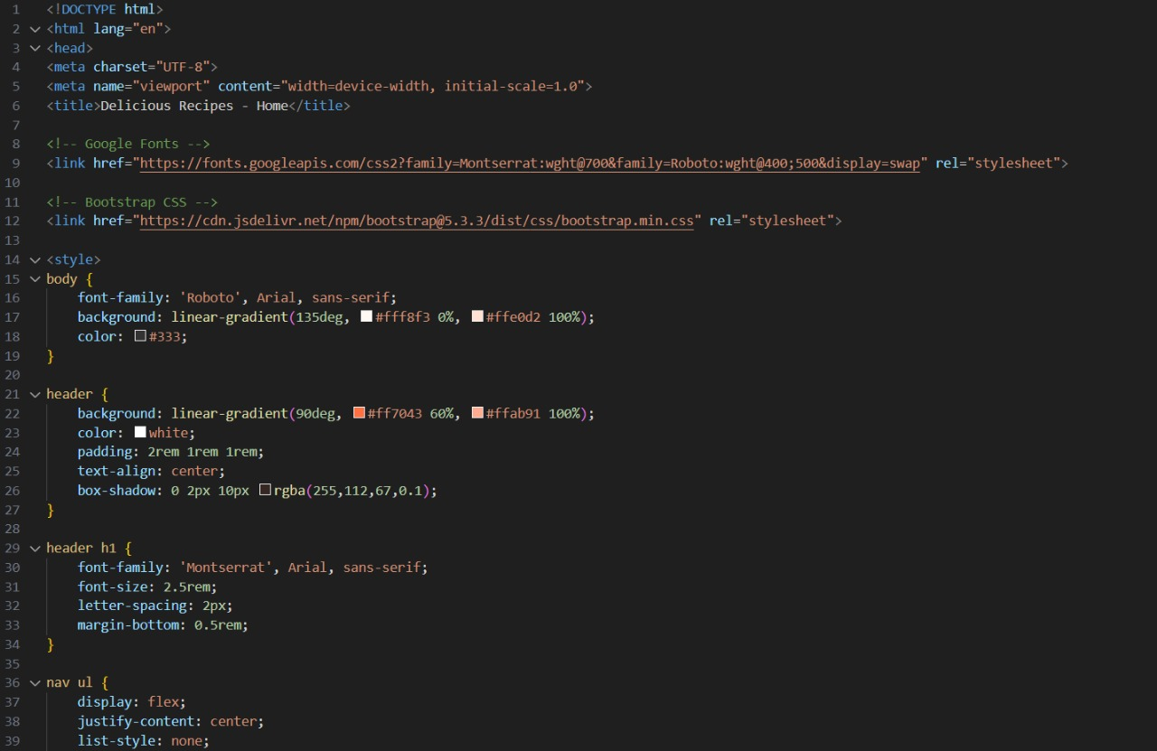

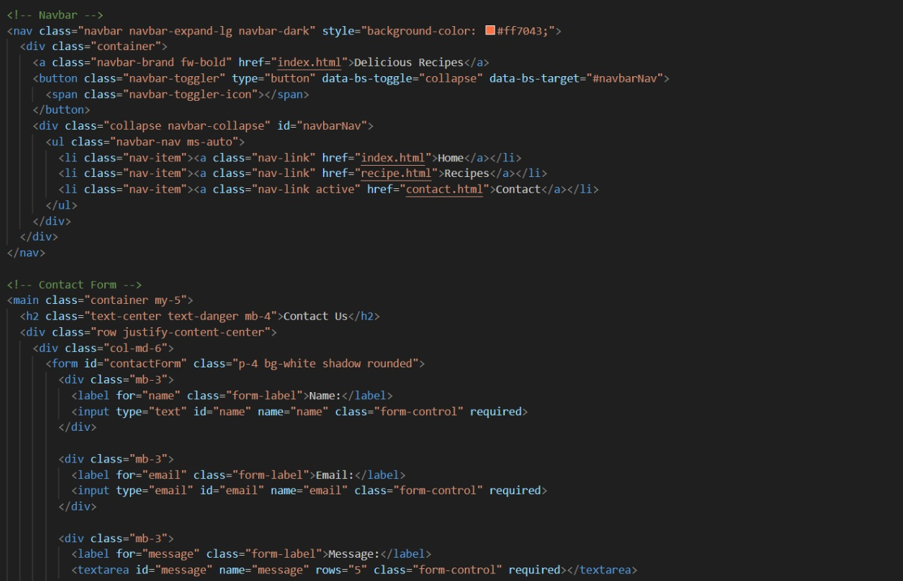

GITHUB LINK: https://amal-kj123.github.io/l-t2/

**Conclusion**

The development of the *l-t2 portfolio website* successfully demonstrates the effective use of front-end web technologies to create a professional, responsive, and user-friendly platform for personal branding. By integrating HTML for structure, CSS for design, and JavaScript for interactivity, the project delivers a clean and organized interface that showcases academic background, personal details, and project work in a visually appealing manner.

Throughout the process, various challenges such as layout design, responsiveness, and performance optimization were encountered and addressed with practical solutions. This not only enhanced technical proficiency but also strengthened problem-solving skills. The deployment of the website on GitHub Pages further provided valuable experience in version control and live hosting, ensuring accessibility for a global audience.

The outcomes highlight the portfolio’s role as both a learning experience and a professional tool. It serves as a foundation for continuous improvement, with possibilities for future enhancements such as interactive forms, advanced animations, and backend integration. Overall, the project has achieved its objectives of creating a digital identity, improving technical knowledge, and building a scalable platform for showcasing future growth.

**References**

1. Amal K J. (2025). *Personal Portfolio Website (l-t2)*. Available at: <https://amal-kj123.github.io/l-t2/>
2. W3Schools. (2025). *HTML Tutorial*. Available at: https://www.w3schools.com/html/
3. W3Schools. (2025). *CSS Tutorial*. Available at: https://www.w3schools.com/css/
4. W3Schools. (2025). *JavaScript Tutorial*. Available at: https://www.w3schools.com/js/
5. Mozilla Developer Network (MDN). (2025). *HTML, CSS, and JavaScript Documentation*. Available at: https://developer.mozilla.org/
6. GitHub Docs. (2025). *GitHub Pages Documentation*. Available at: https://docs.github.com/en/pages
7. FreeCodeCamp. (2025). *Responsive Web Design Principles*. Available at: https://www.freecodecamp.org/